CLOUD COMPUTING  
ASSIGNMENT-1  
Create an EC2 Instance and Launch an instance  
Create the EC2instance and connect it through

i) EC2 instant direct connect

ii)SSH Client---pem key pair

iii) SSH client ---putty key pair

Note :- Provide the screenshots for each and everyone steps

SSH client –putty key pair  
click on start lab  
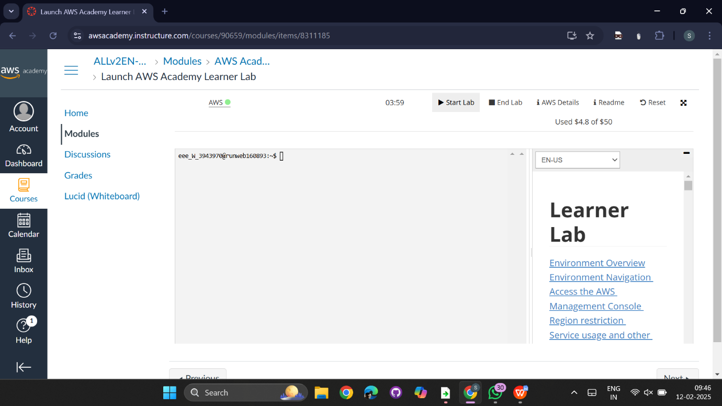  
create and launch an ec2 instance  
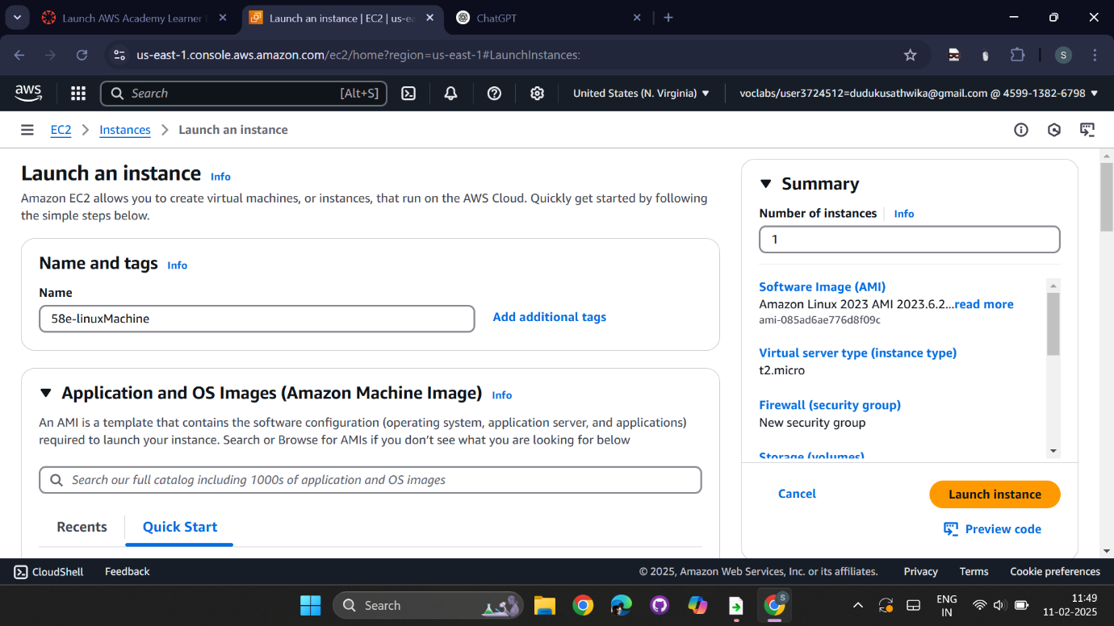

select AMI as Amazon Linux  
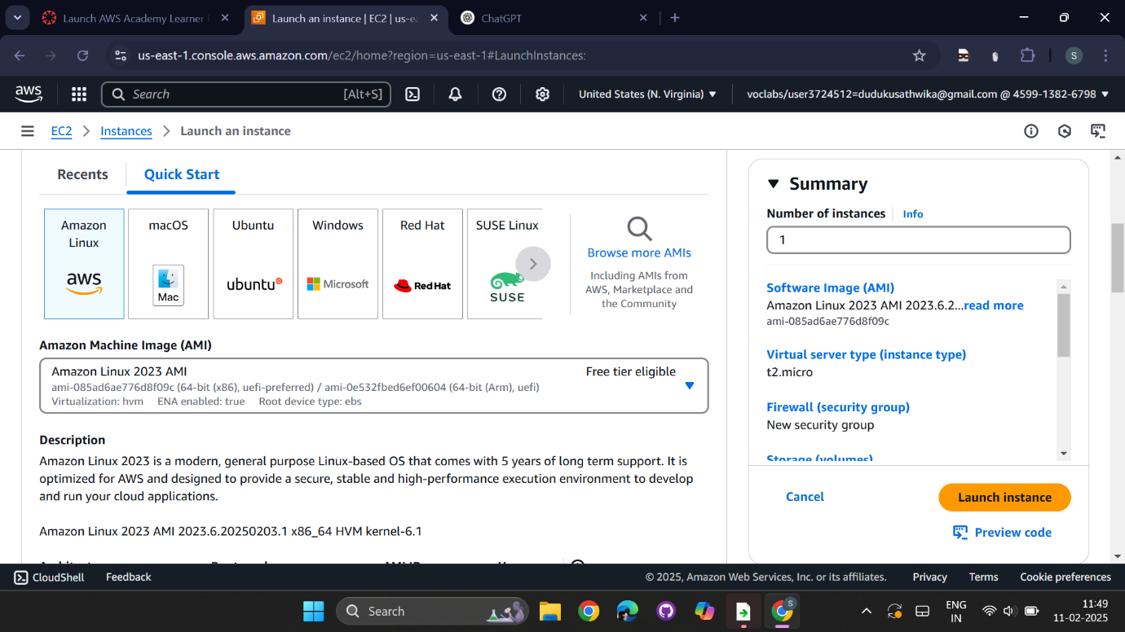

Create or use the already existing key-pair select .ppk and save in your folder

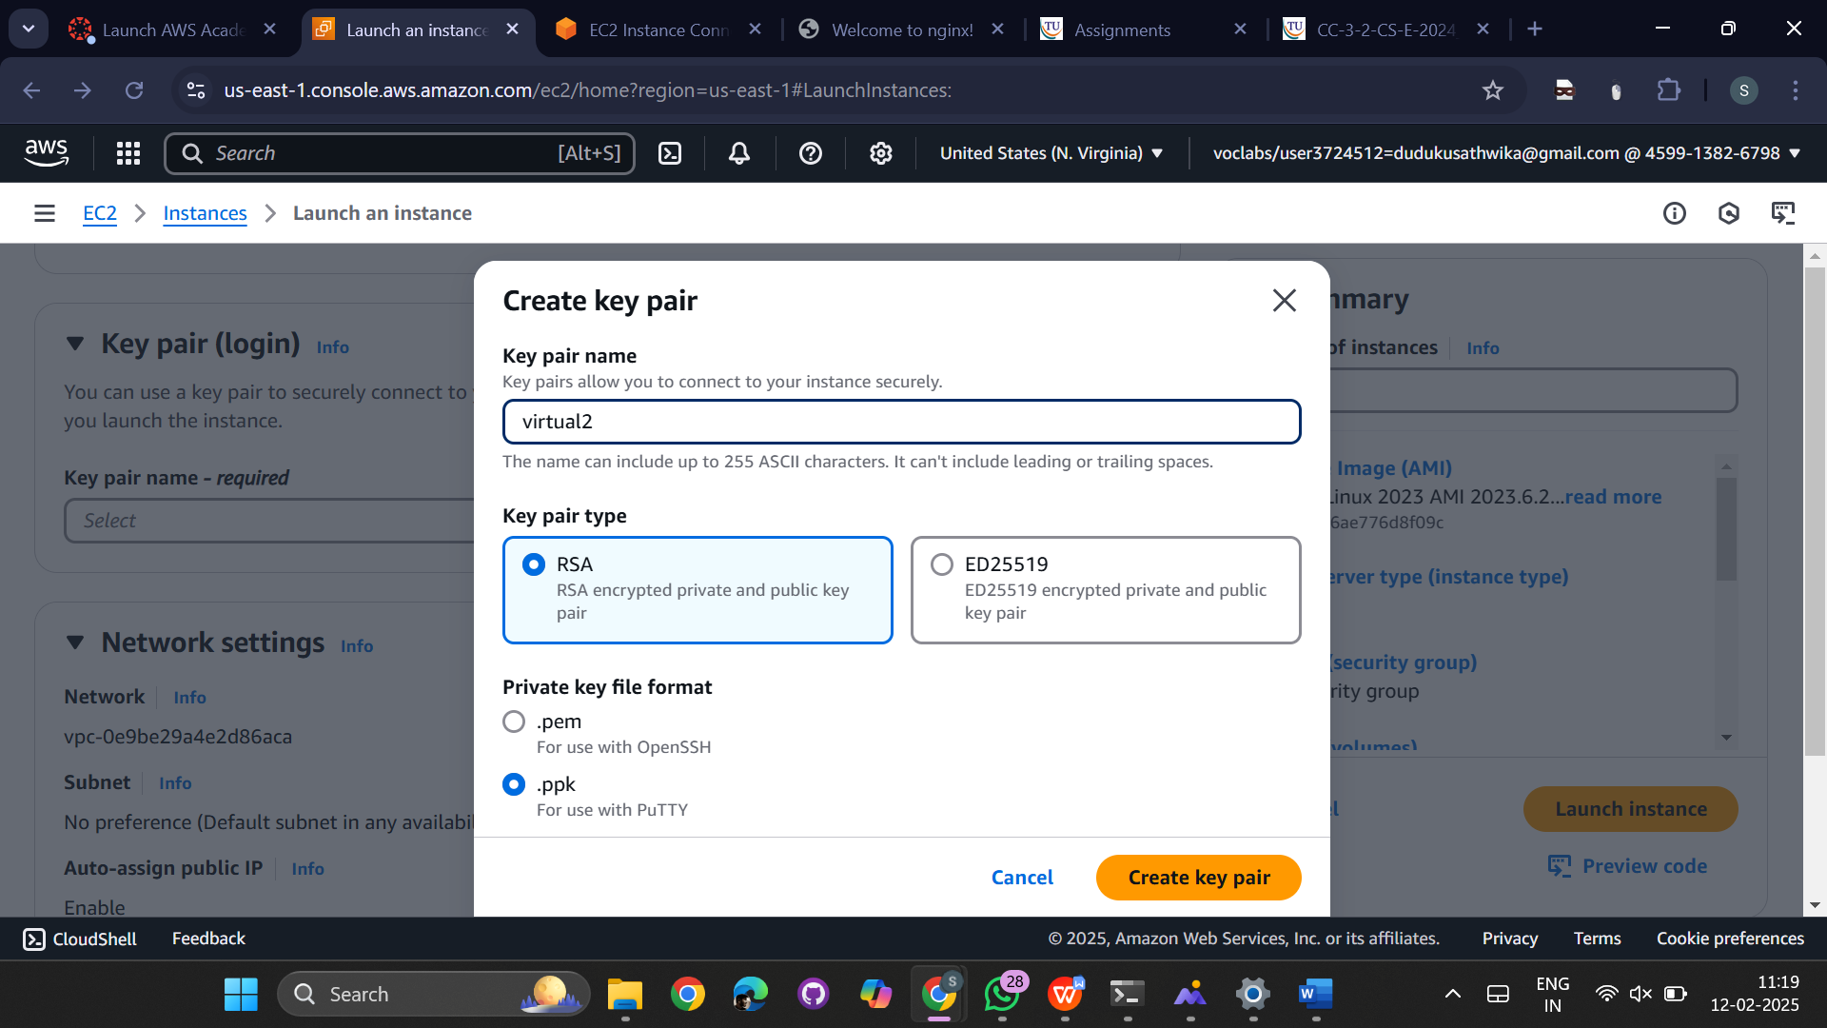

Select instance type t2.micro which is free tier elgible  
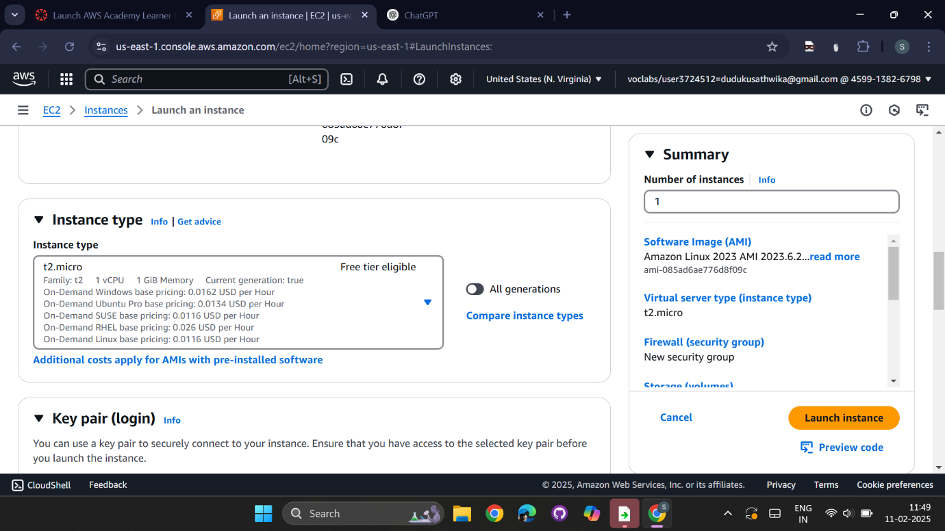

Disable all the security groups   
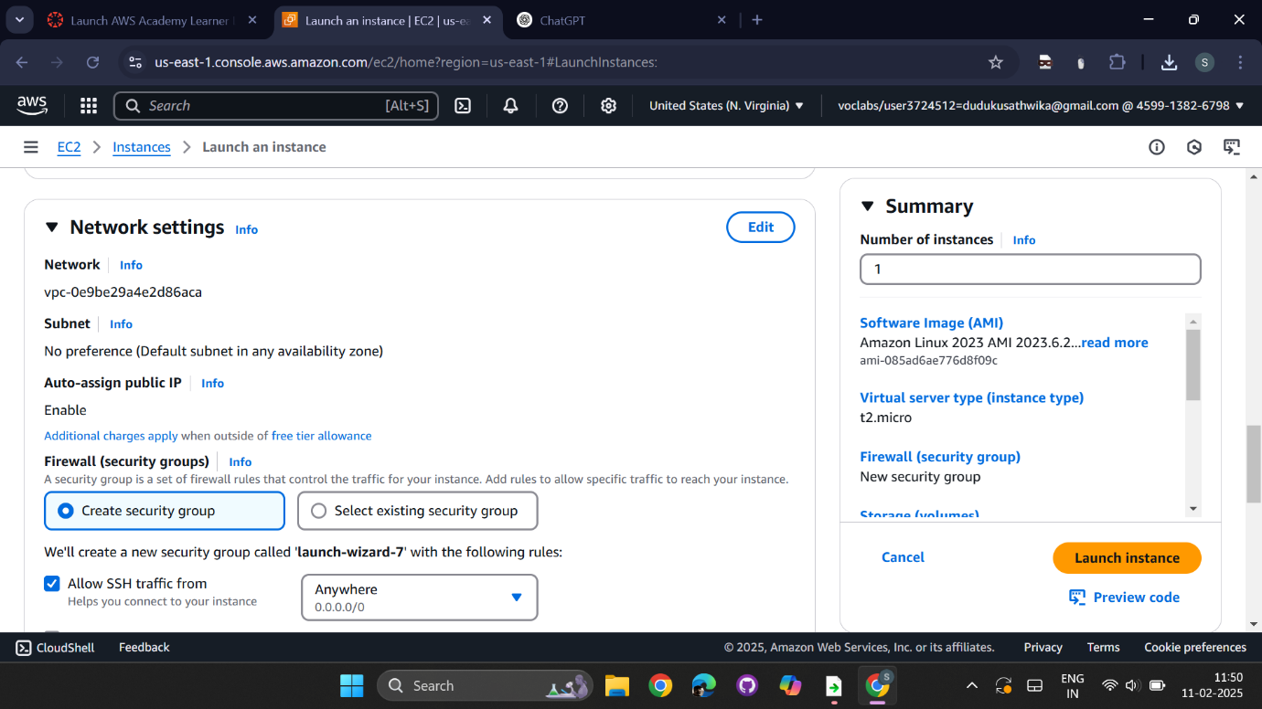  
  
Click on Launch instance

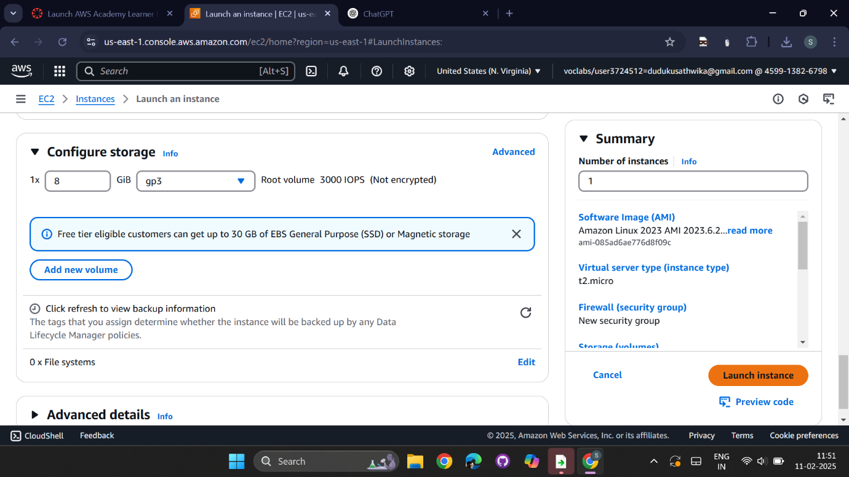

Go to instances  
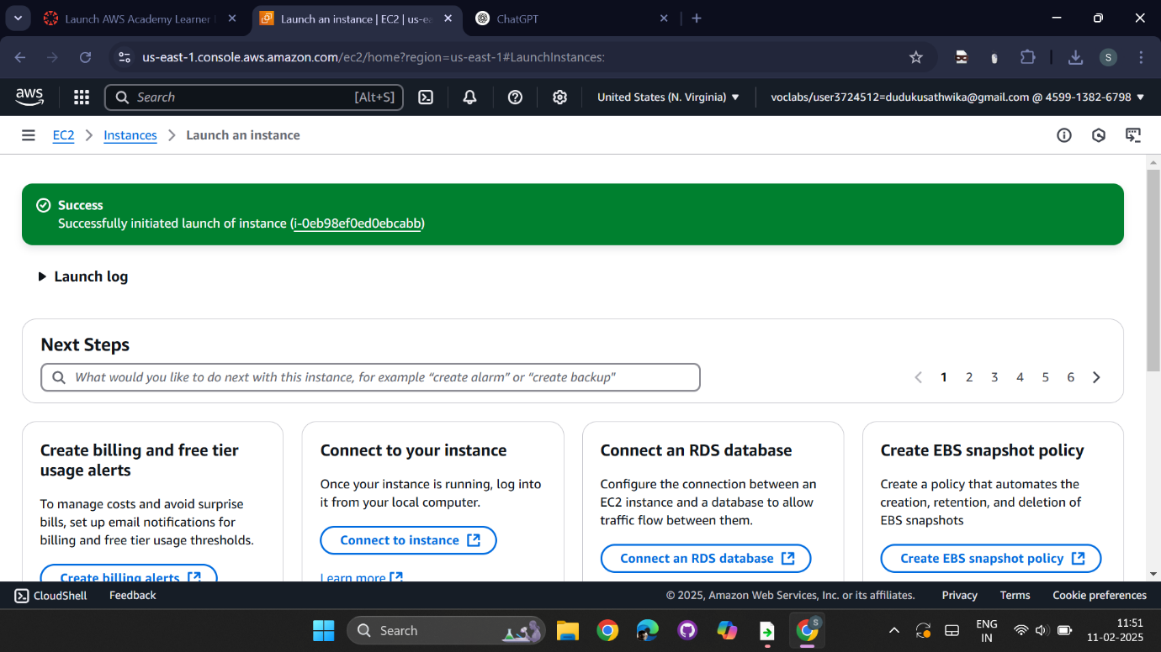  
  
enable the checkbox of the current instance and click on connect   
  
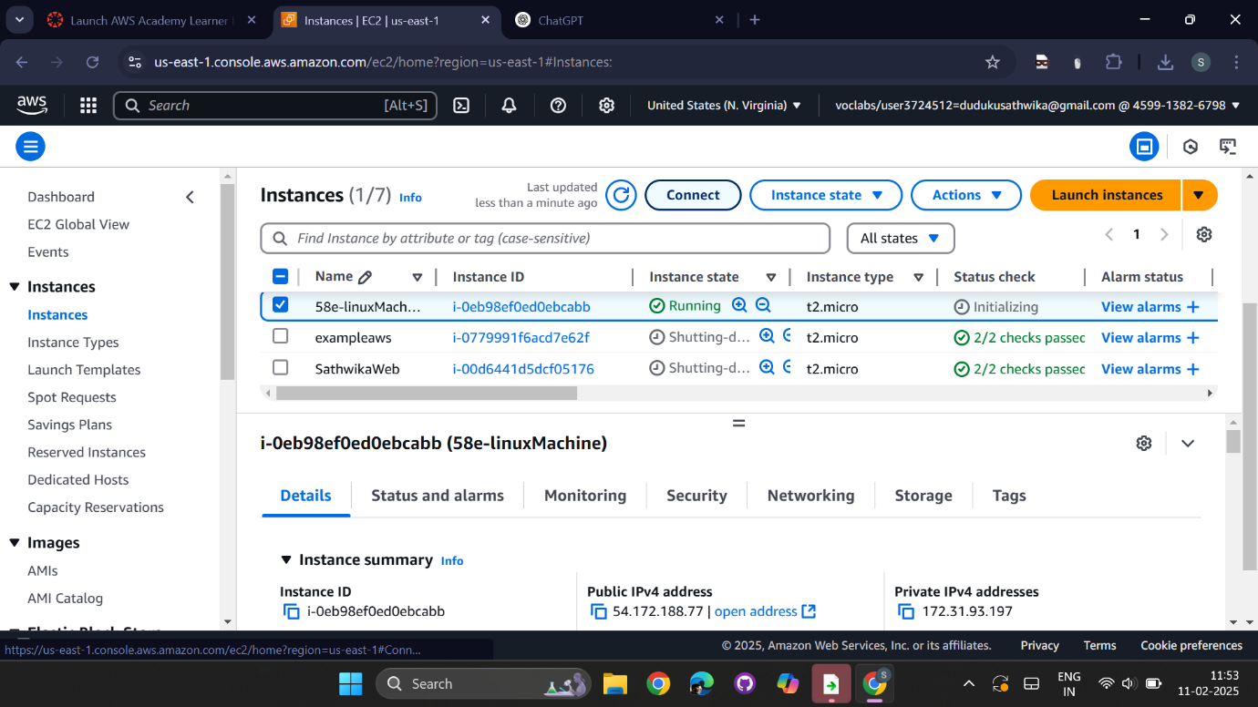

Download putty from the browser  
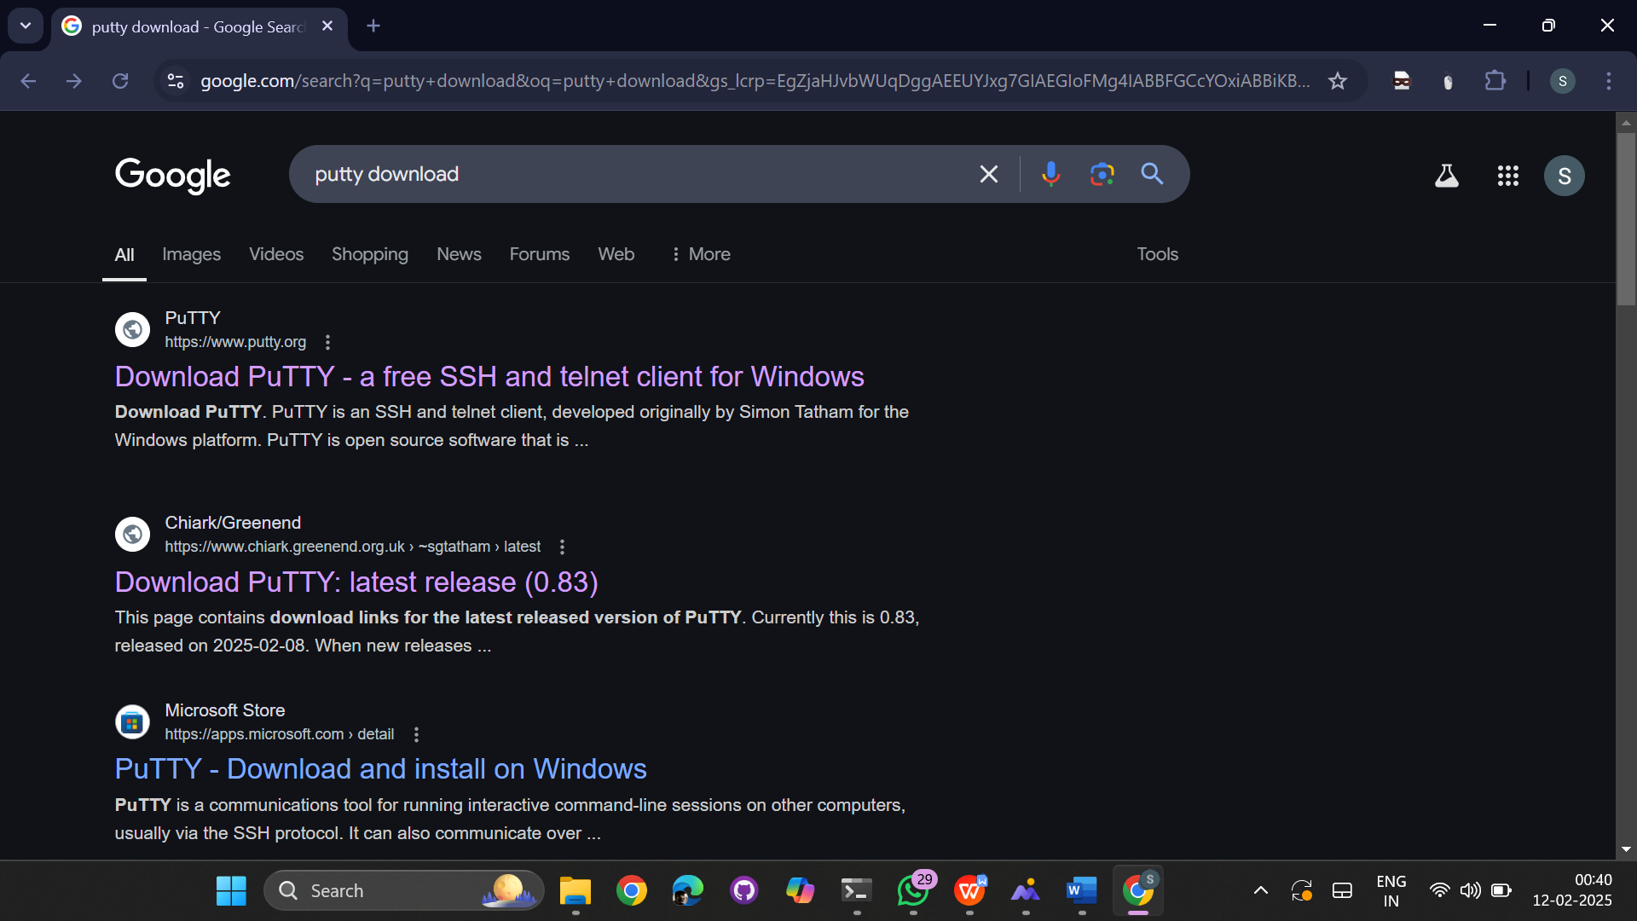  
  
click on download putty  
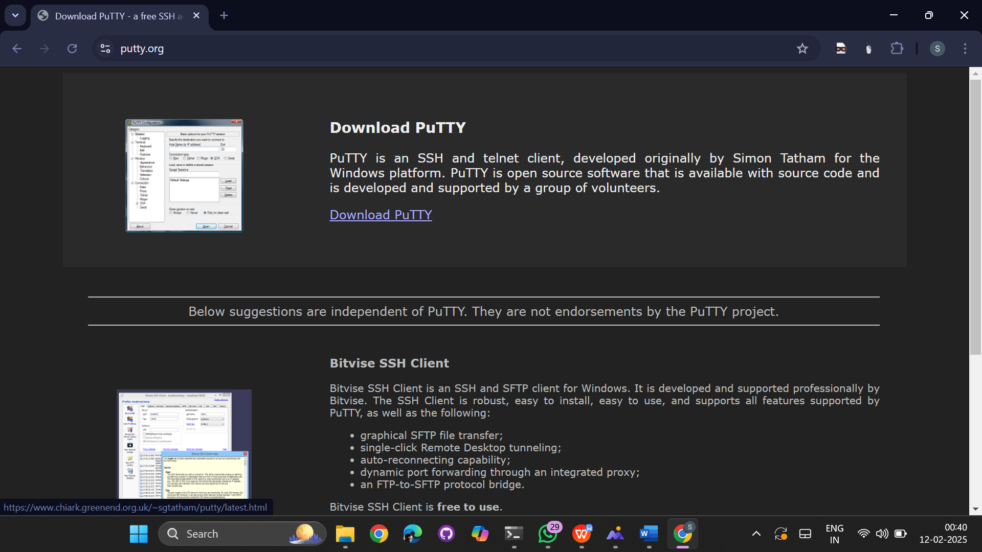

Select 64 bit x86 msi windows installer  
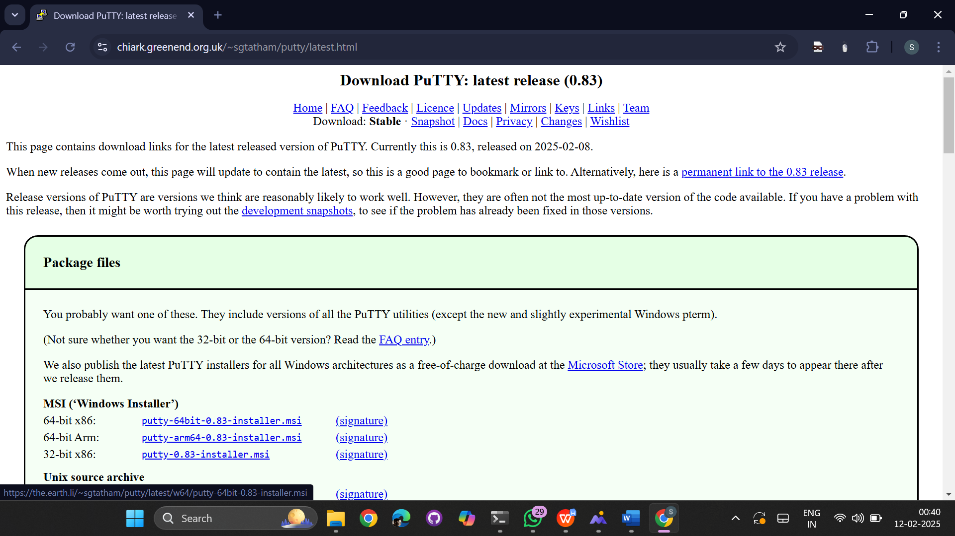

Install the putty in desktop  
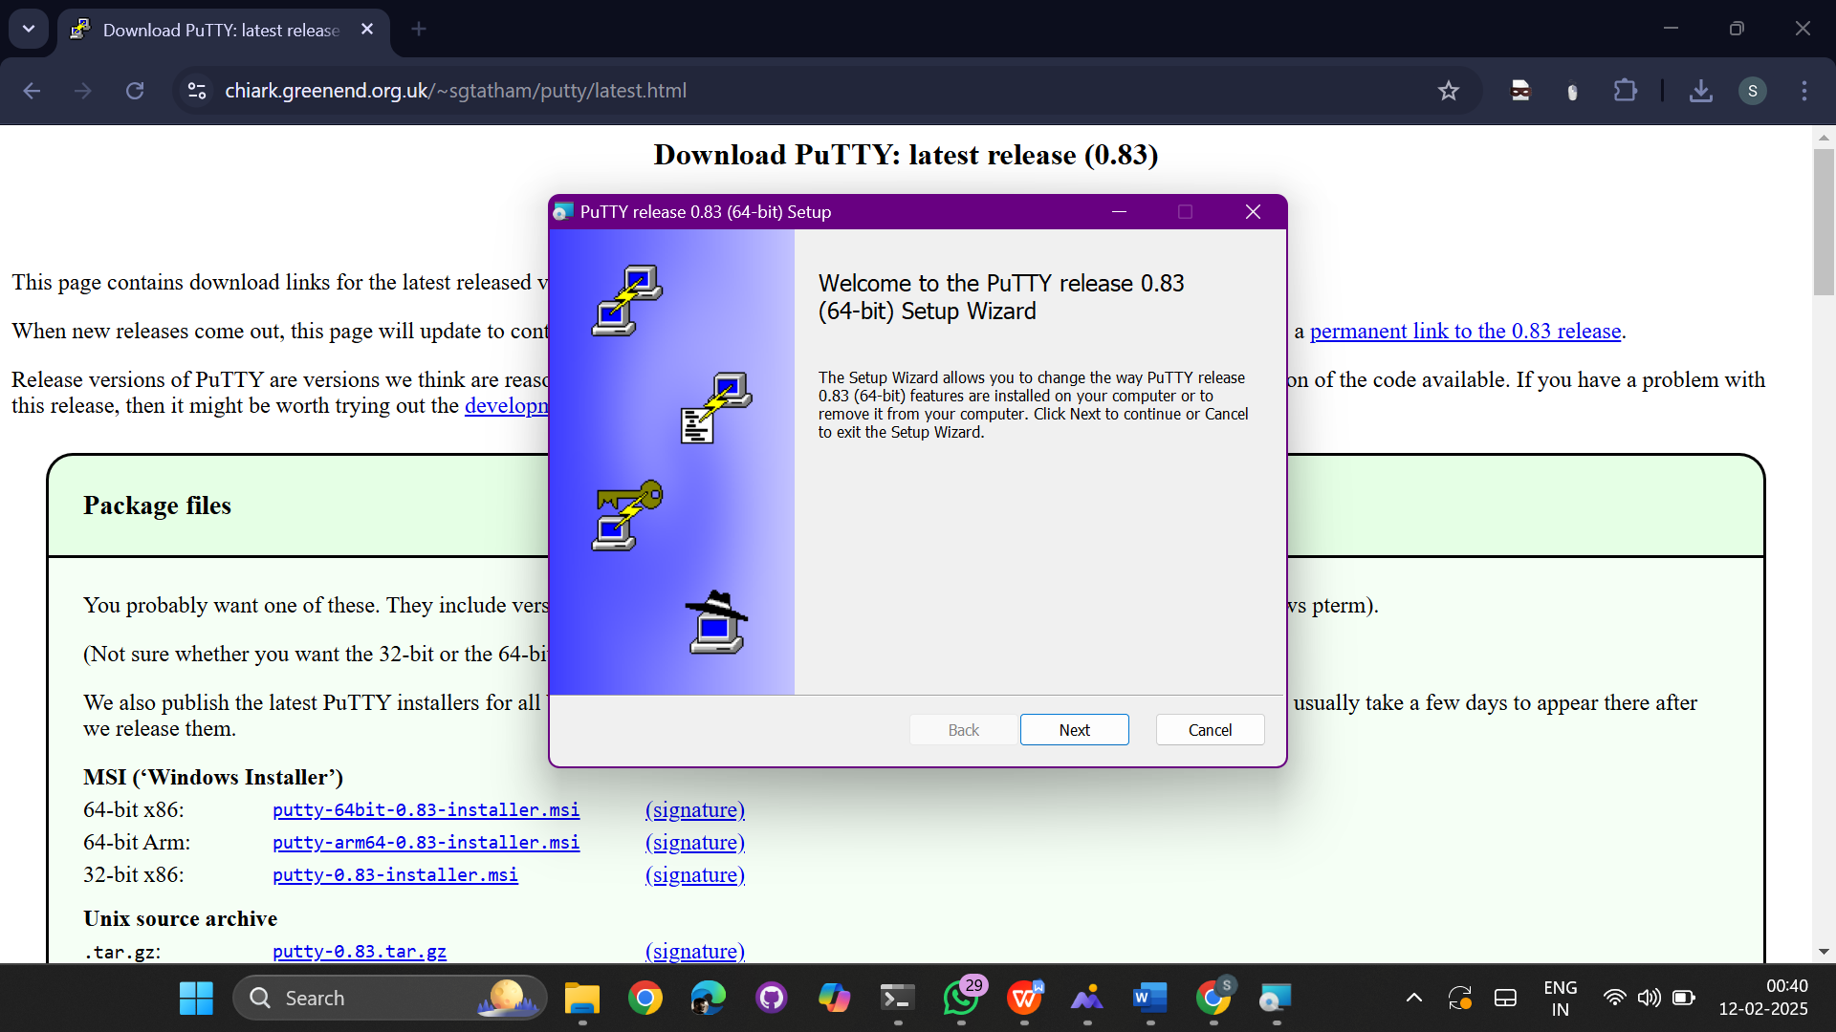

Click on fininsh  
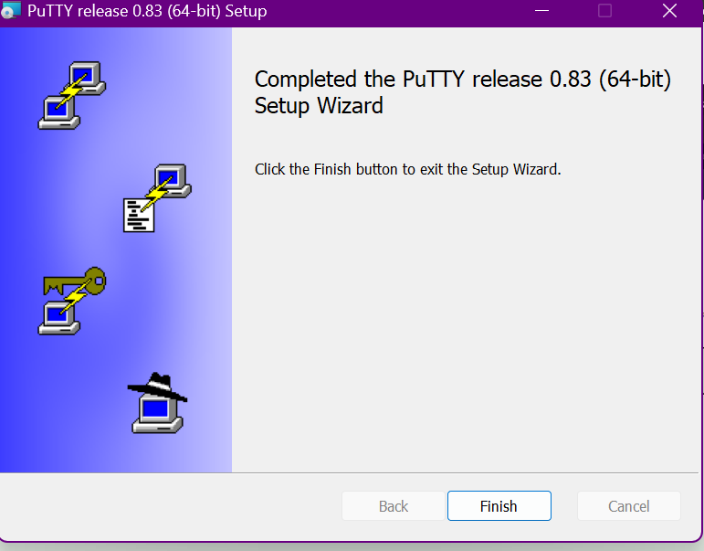

Open putty  
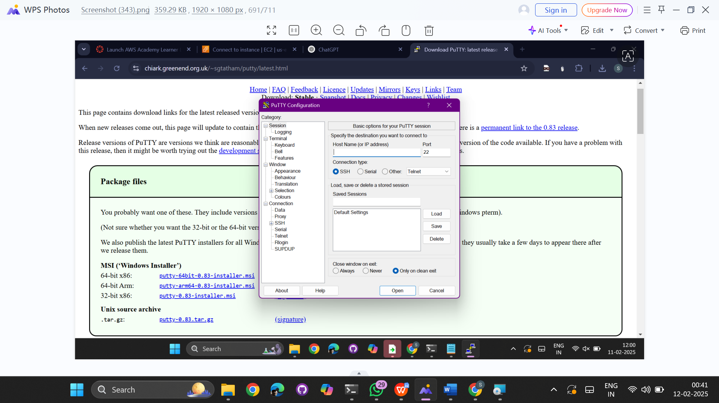

Go to security groups and add rules SSH and All traffic  
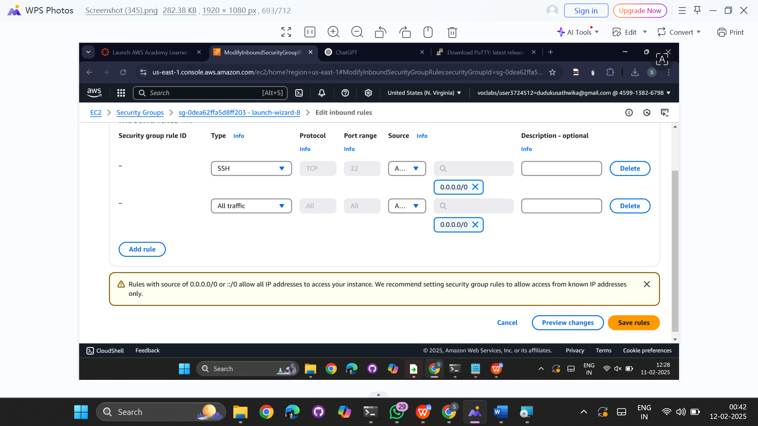

Click on save rules  
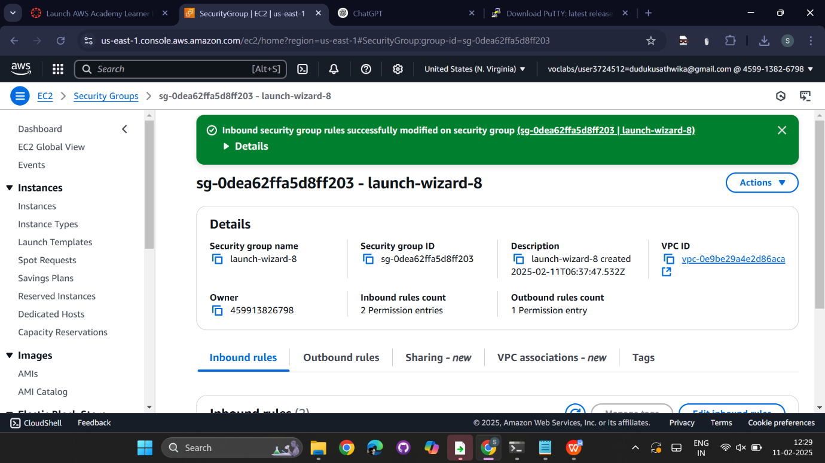

Copy the ssh   
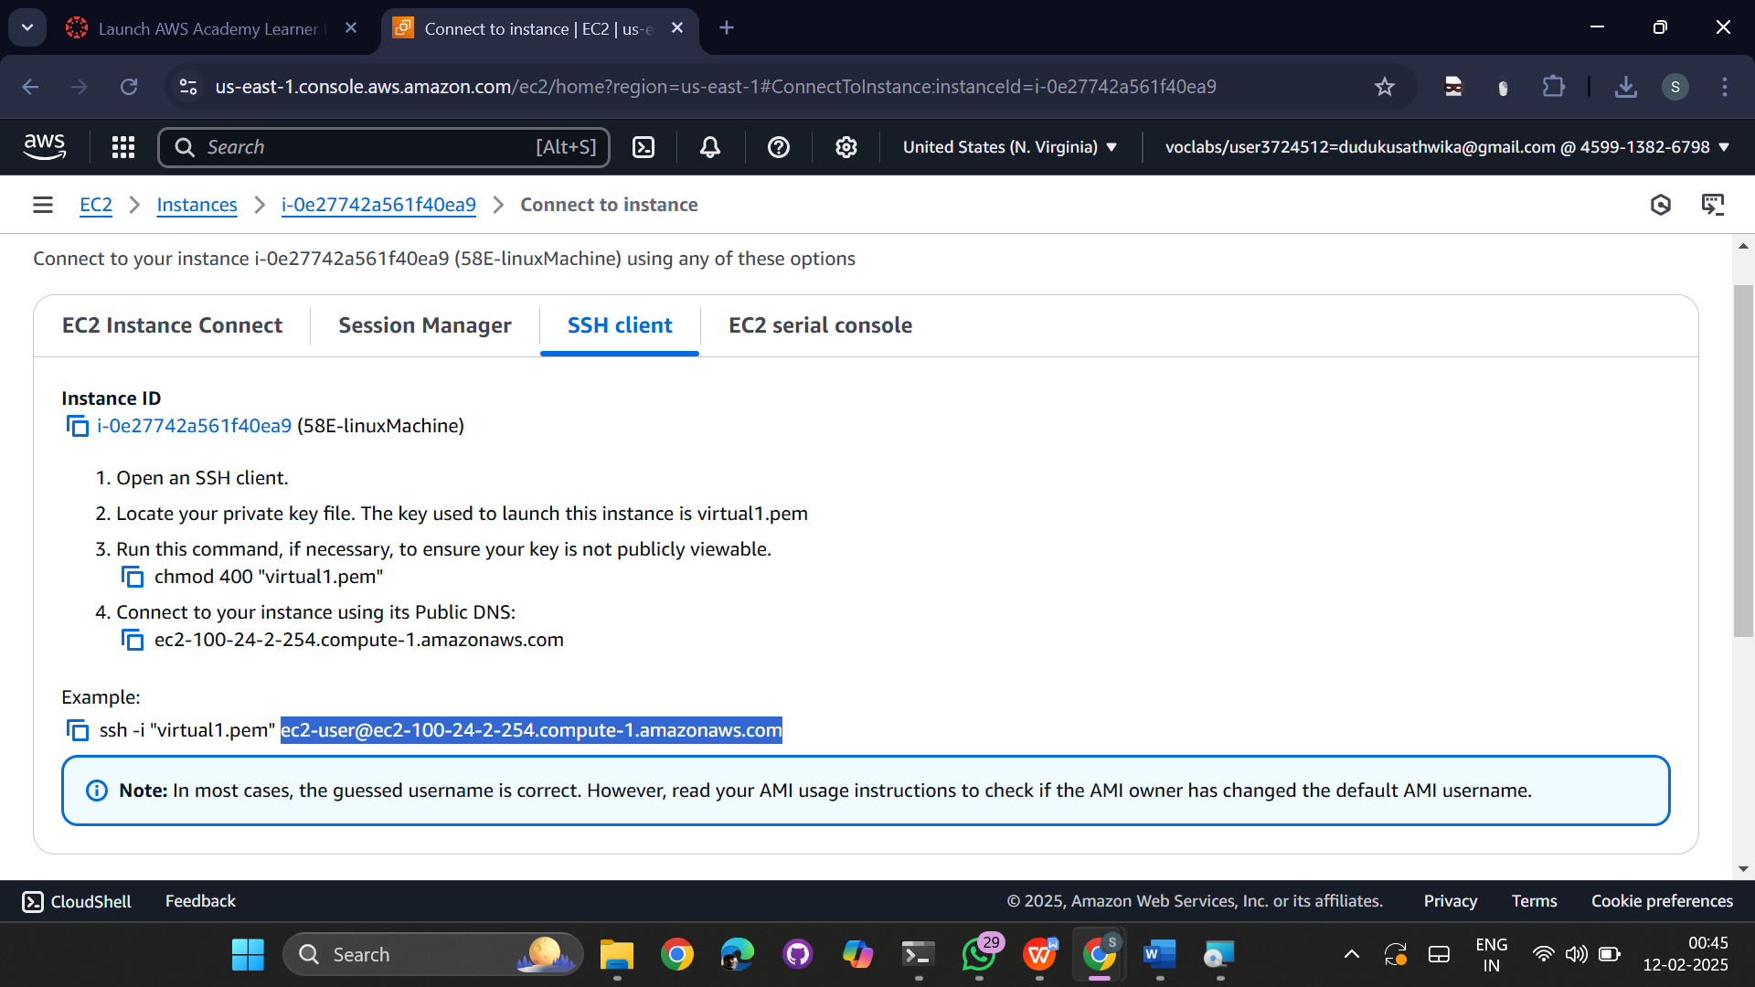  
  
 paste the ssh in host name of putty  
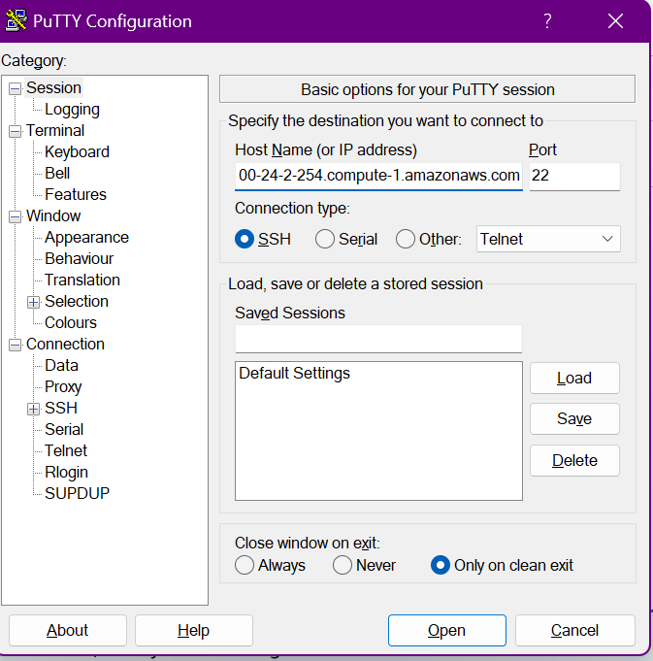

Go to SSH->Auth->Credentials  
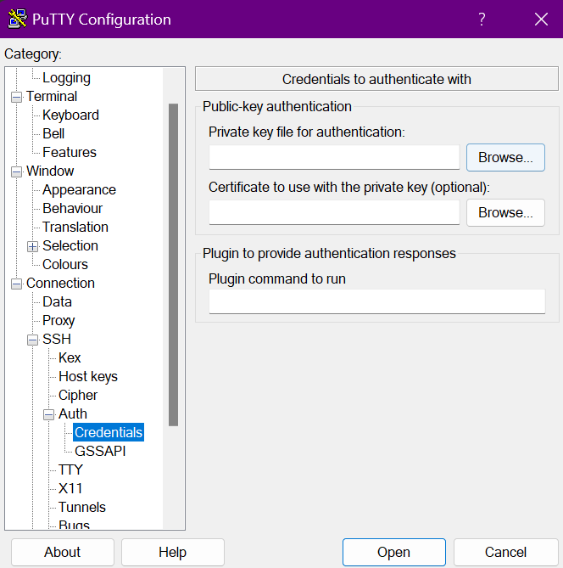

Now browse and select the .ppk key of the instance created  
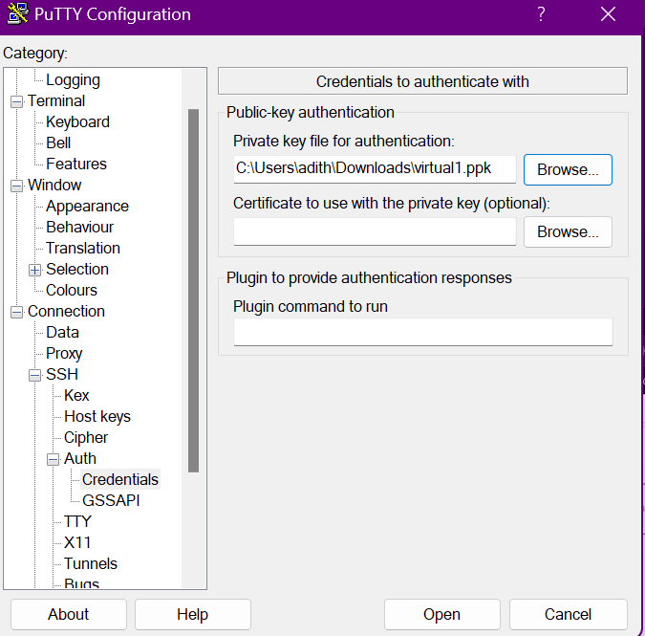

Click on open and accept   
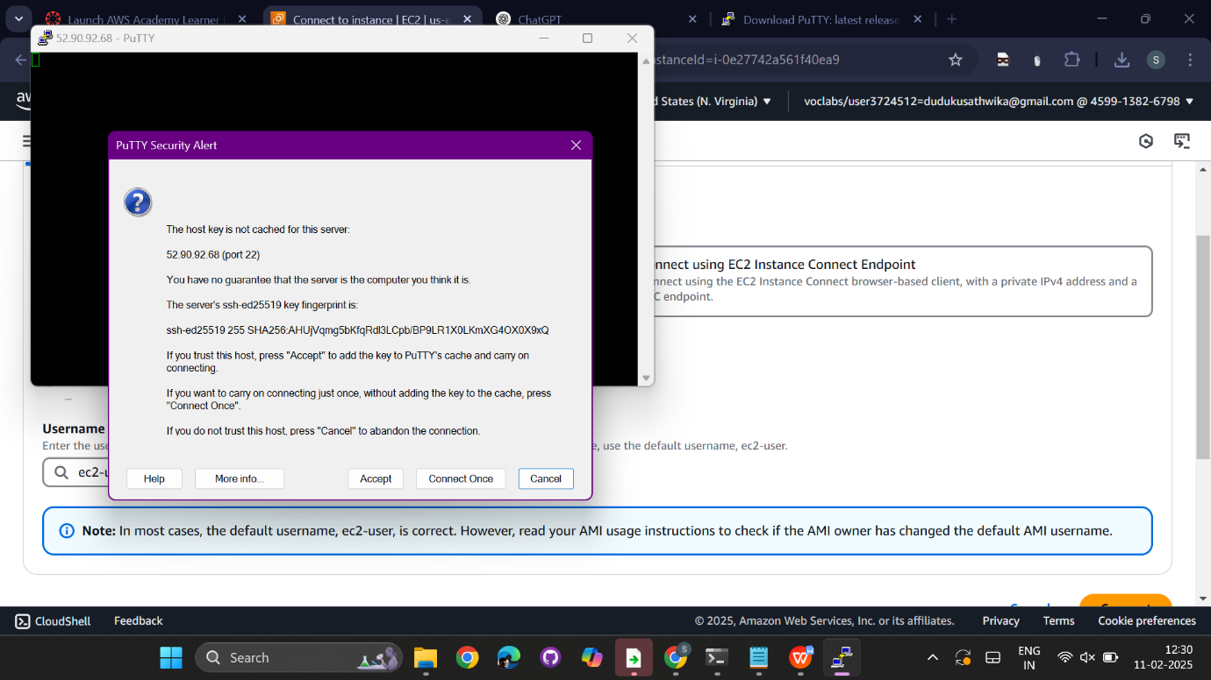

The terminal will be open

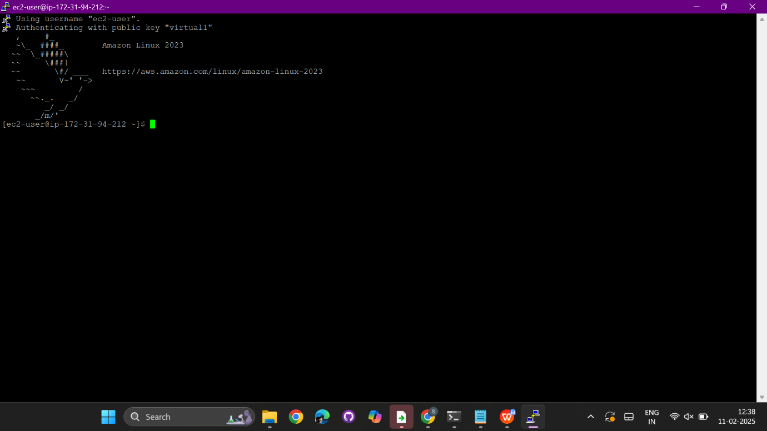  
  
sudo yum update -y  
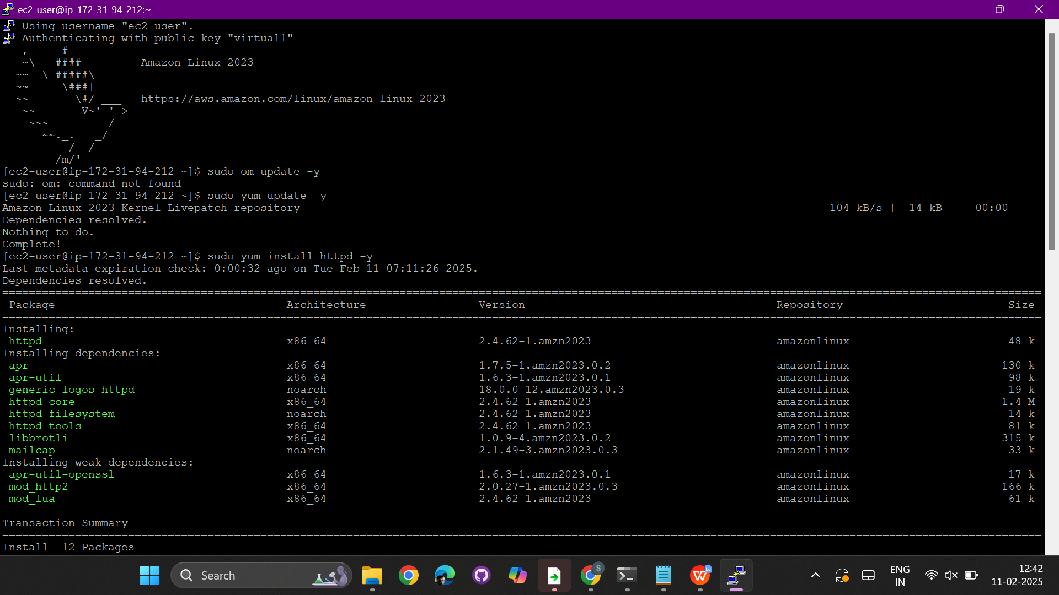  
  
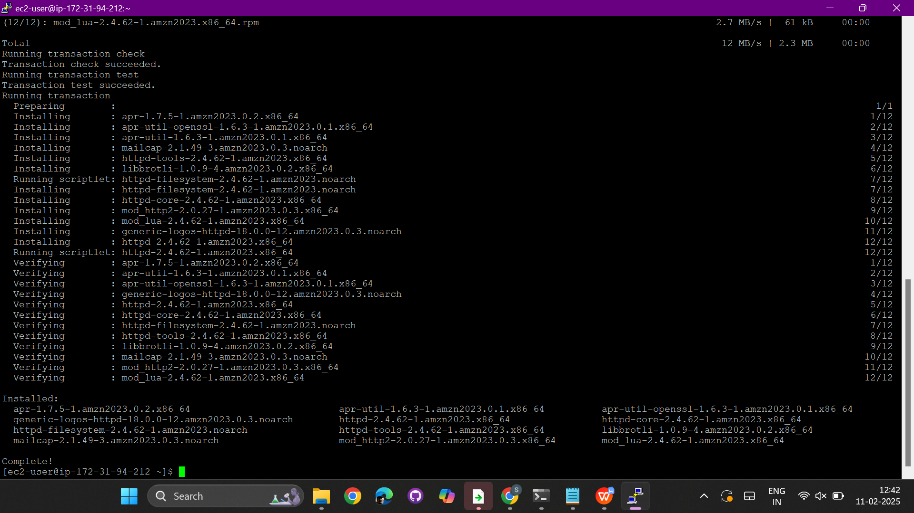  
  
sudo systemctl status httpd  
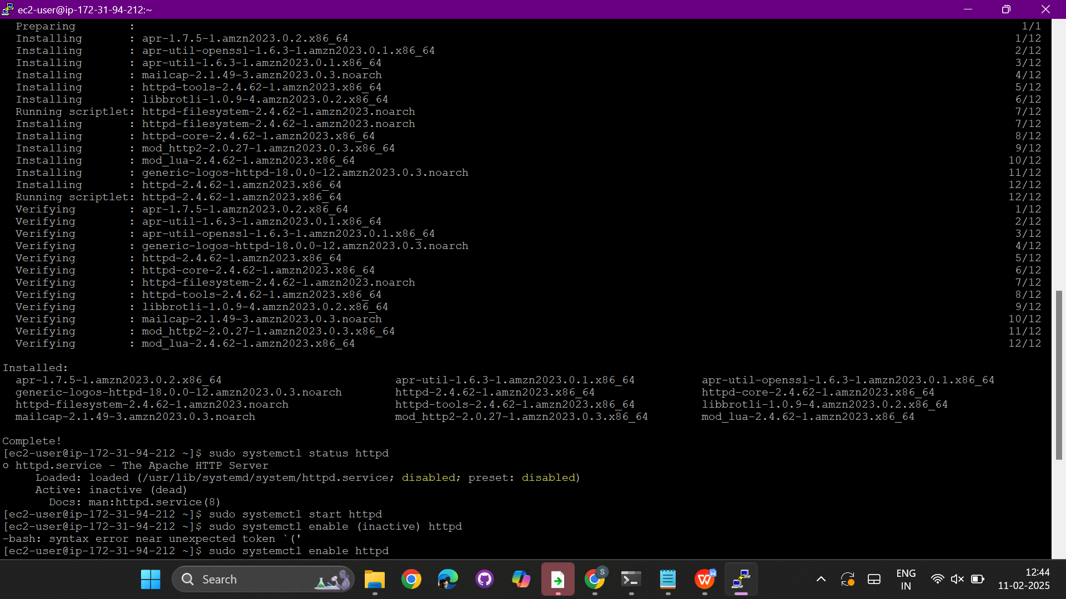  
  
  
  
  
  
sudo systemctl status httpd  
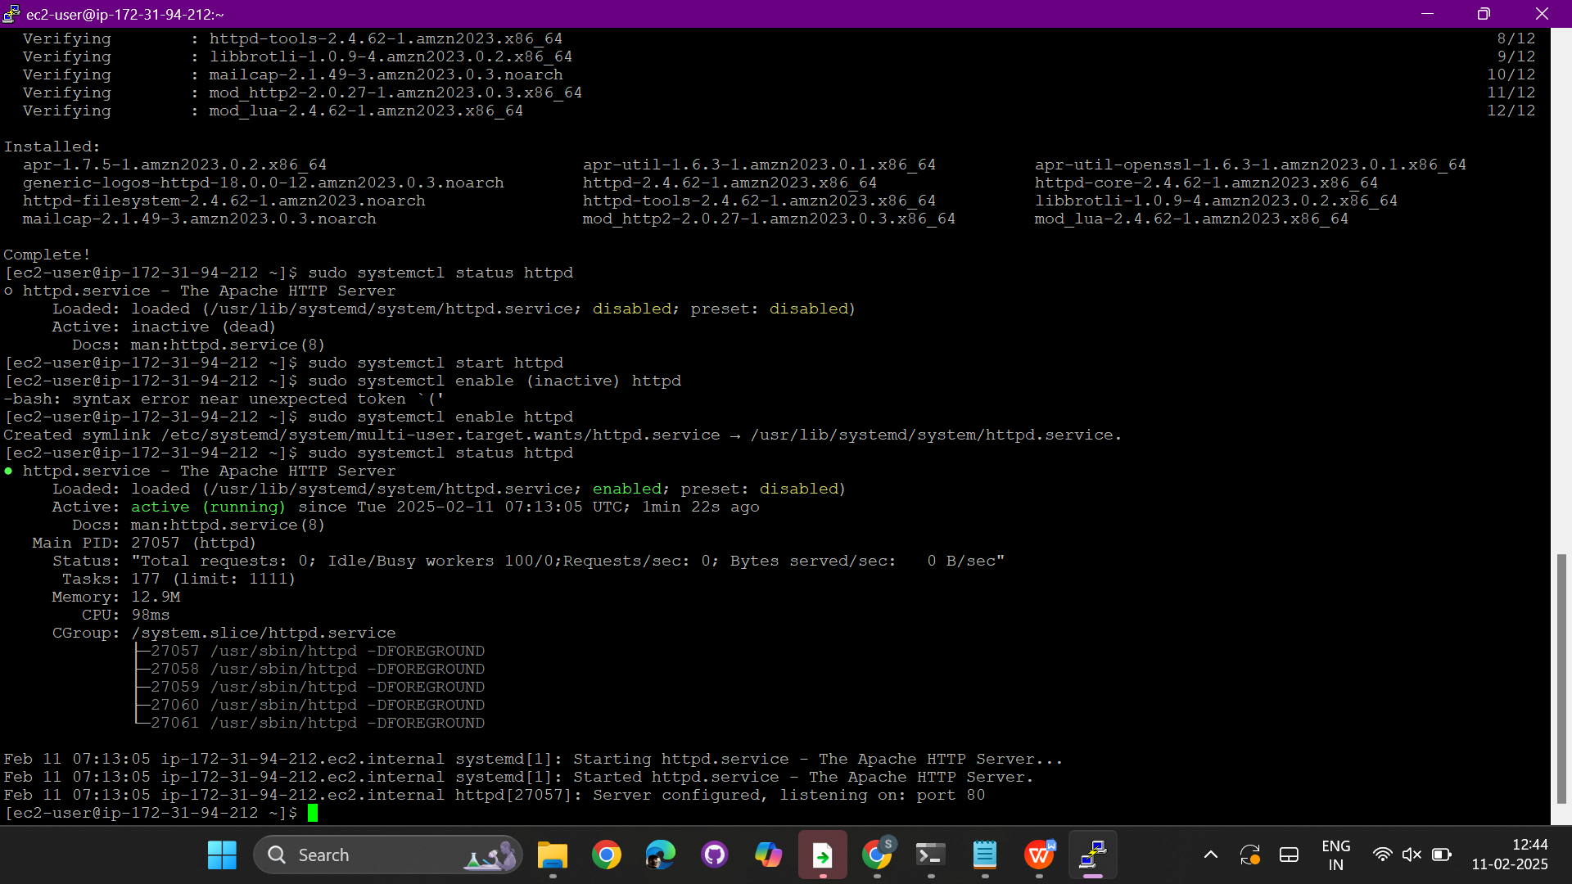

Copy the public ipv4   
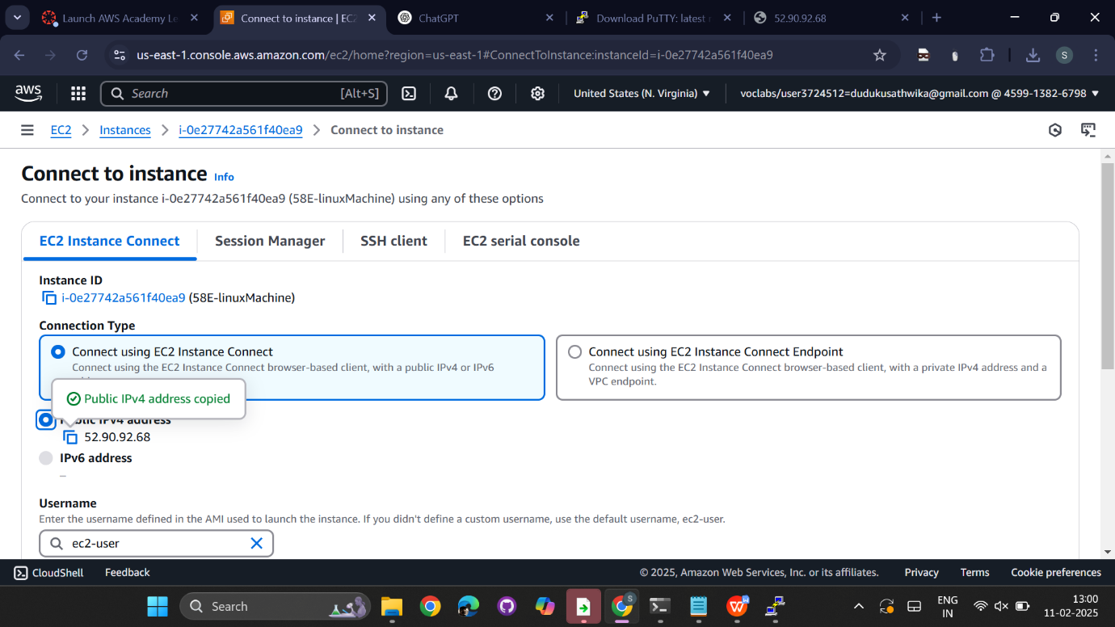  
 open it in the browser  
  
  
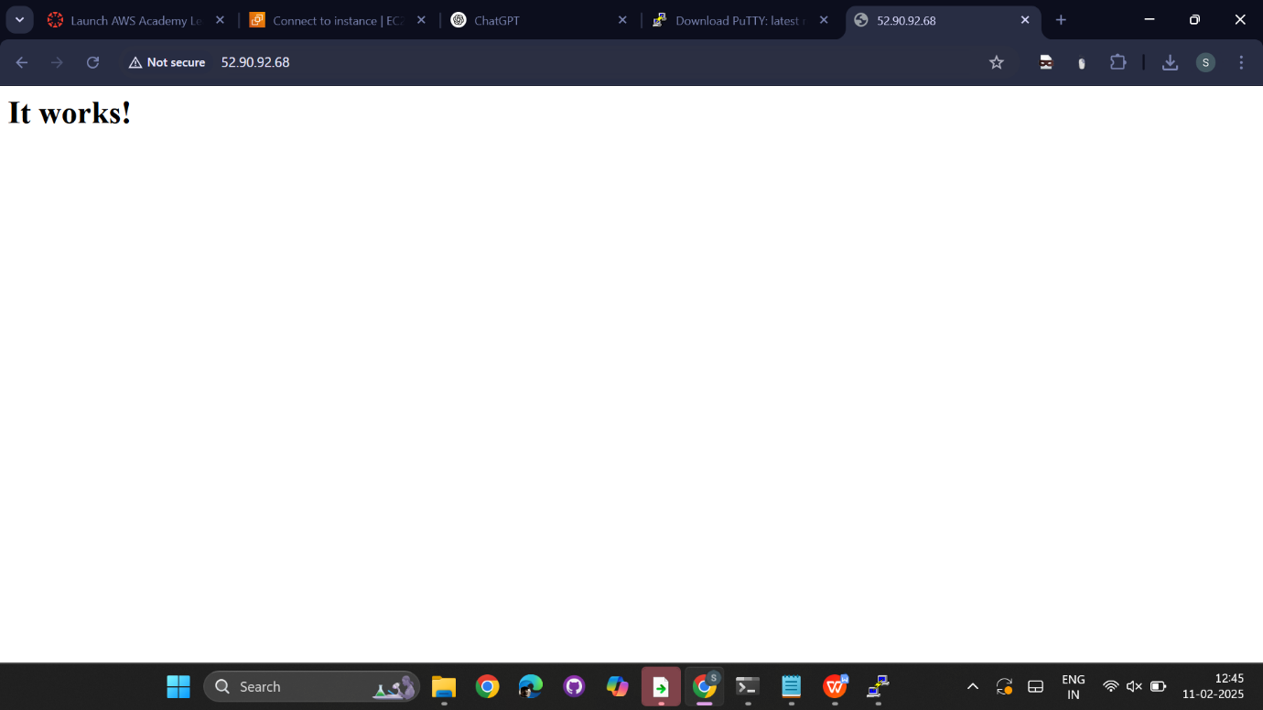

SSH client –pem key  
  
  
  
create and launch an EC2 instance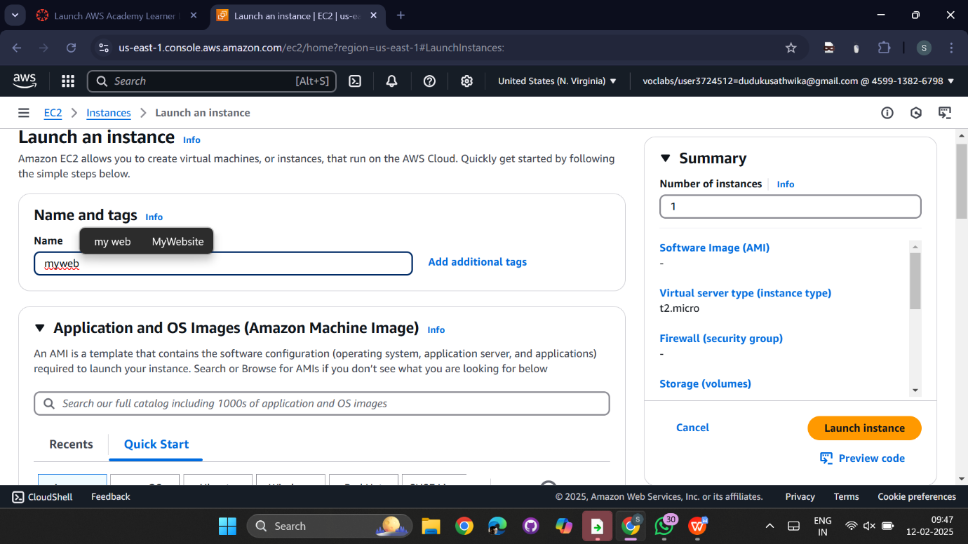  
  
select ubuntu os and select AMI which is free tier  
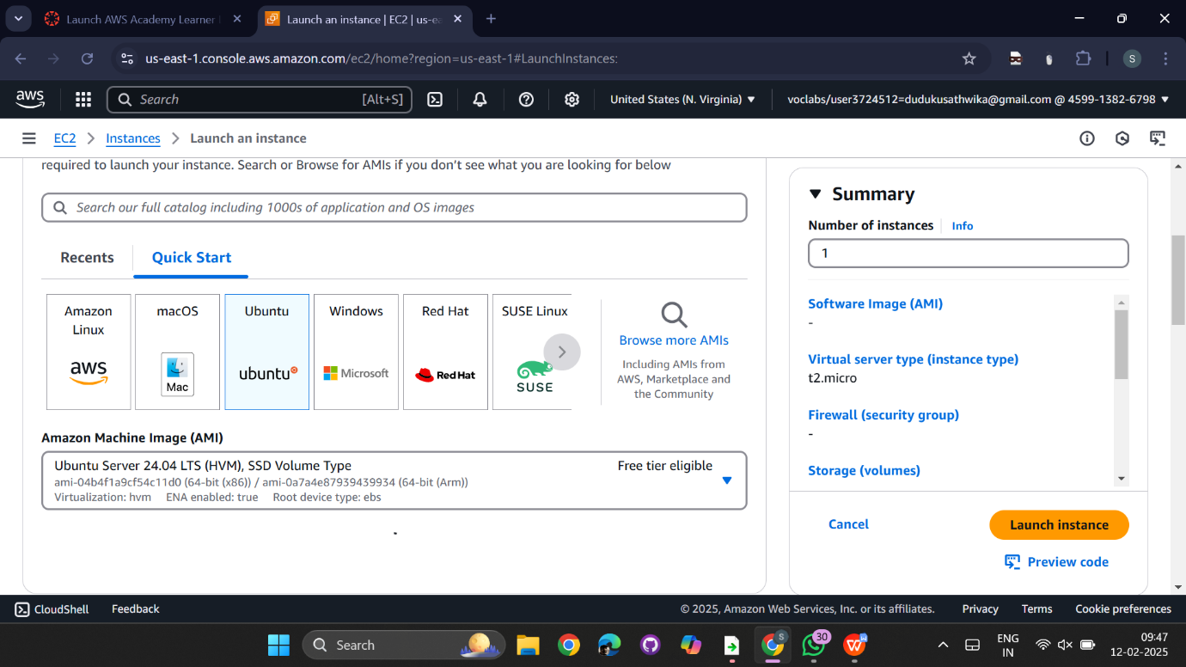  
  
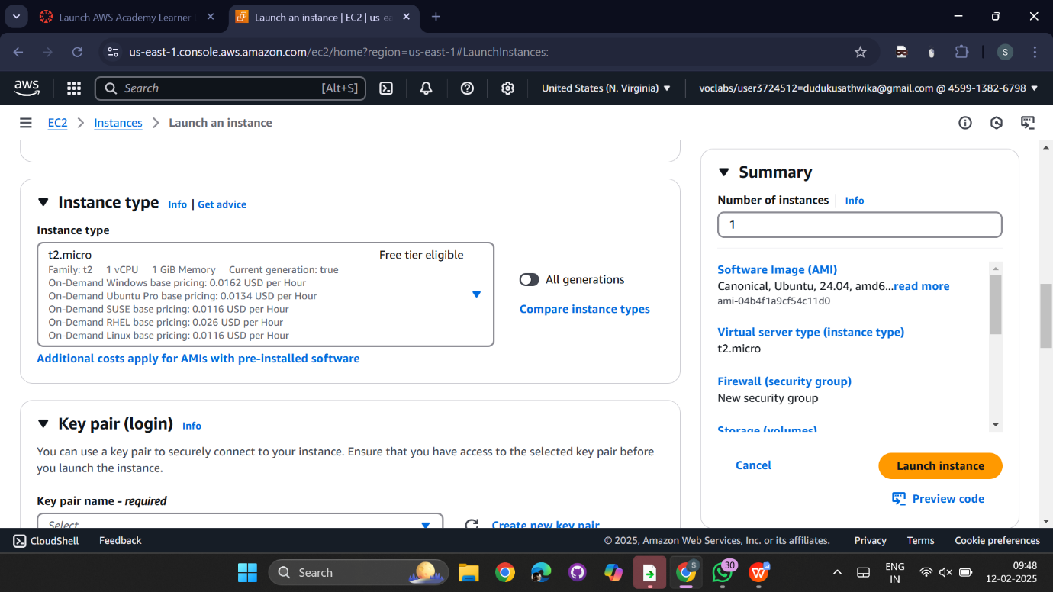

create new key pair   
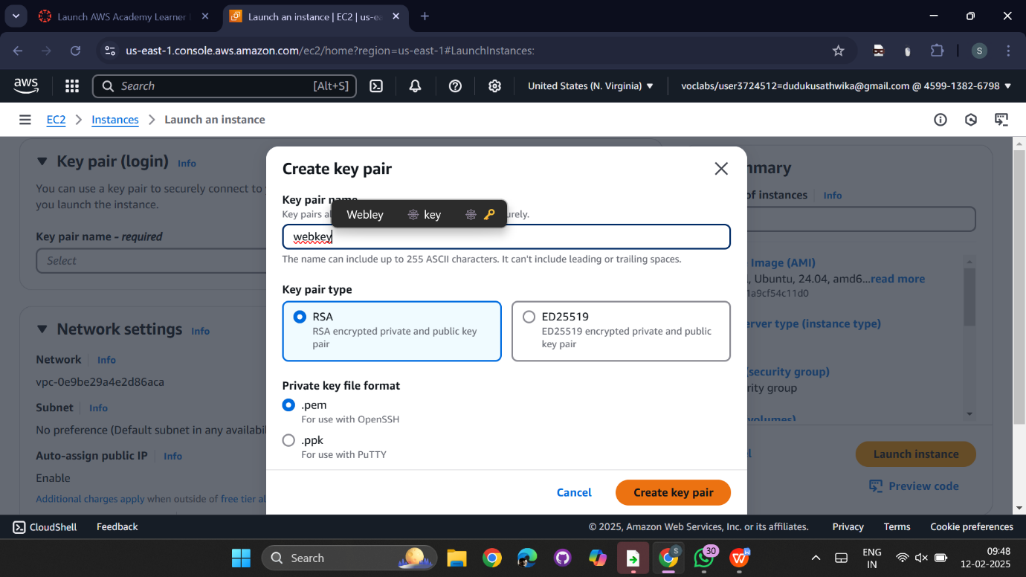

Enable all security groups  
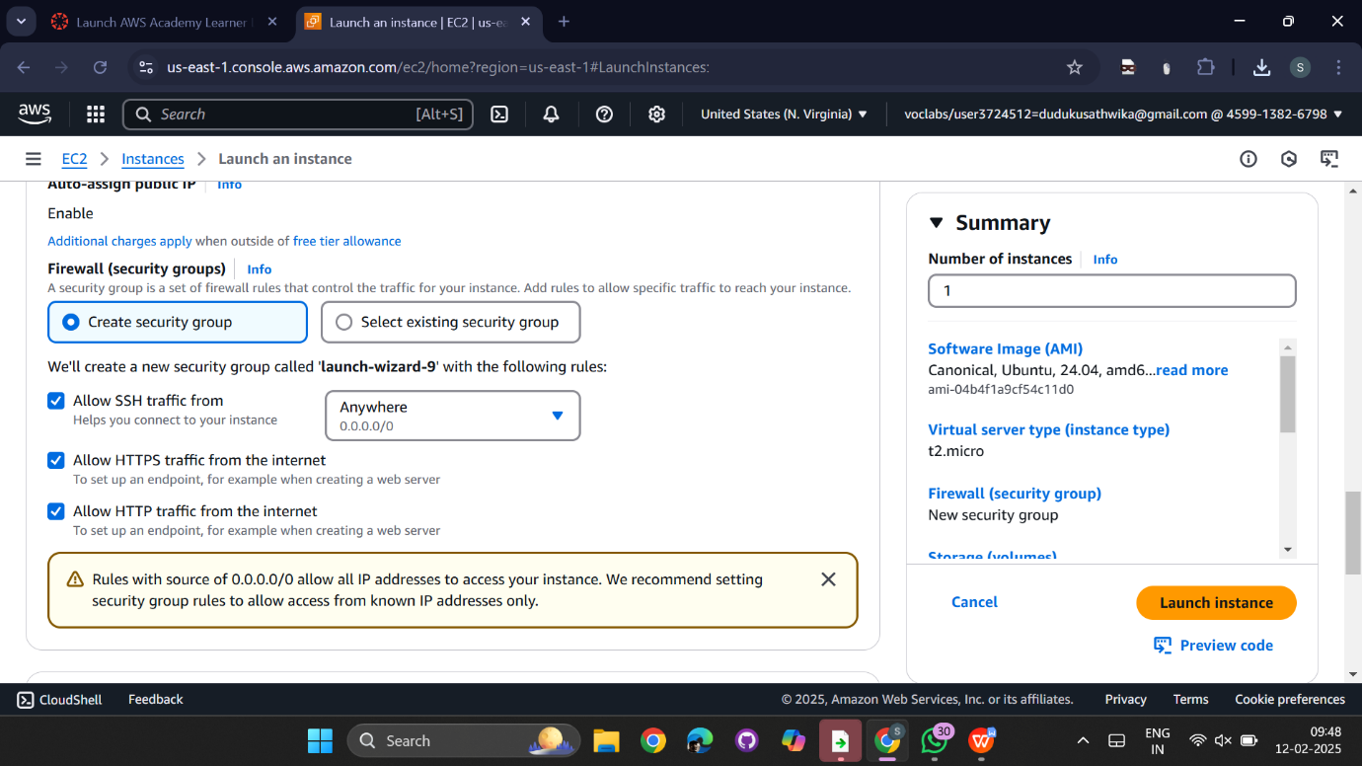  
  
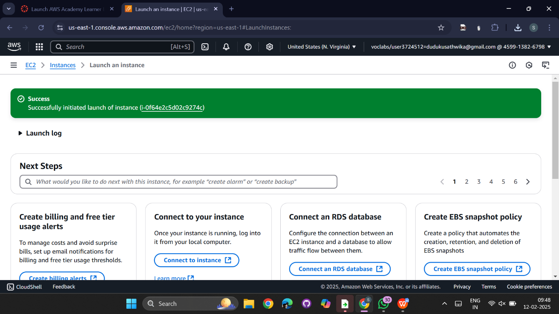  
  
  
copy the ssh  
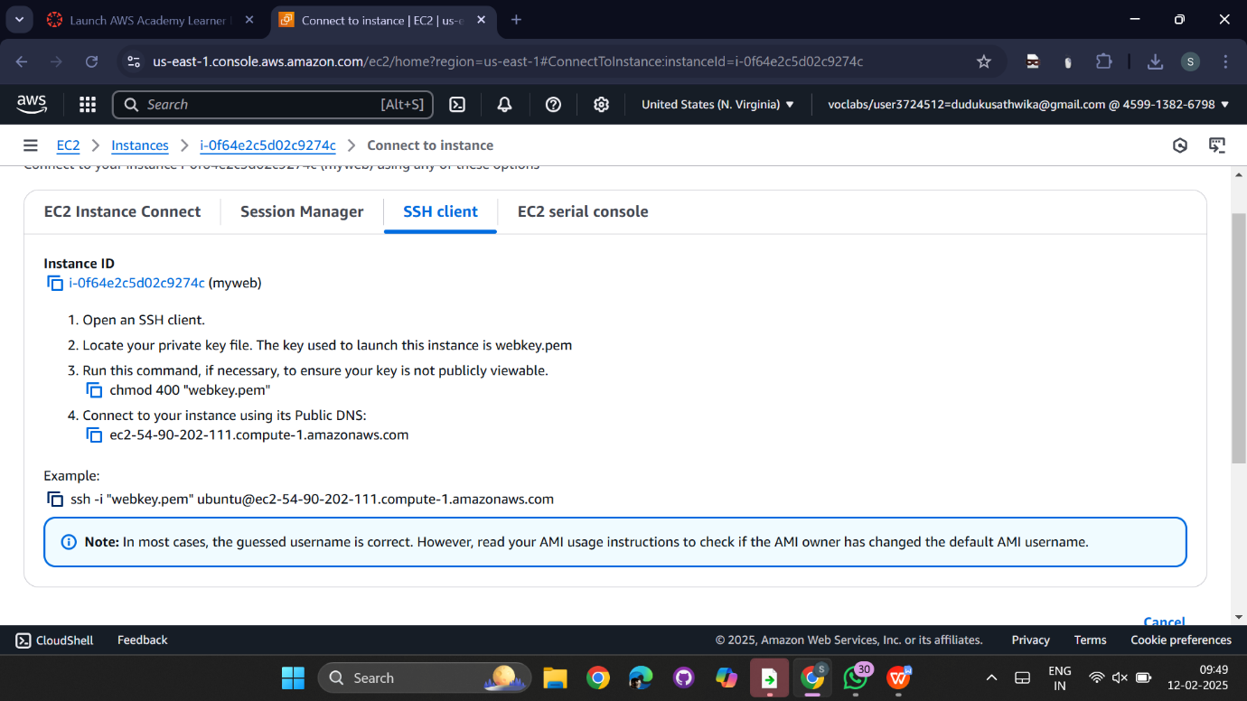

open powershell and paste the copied ssh   
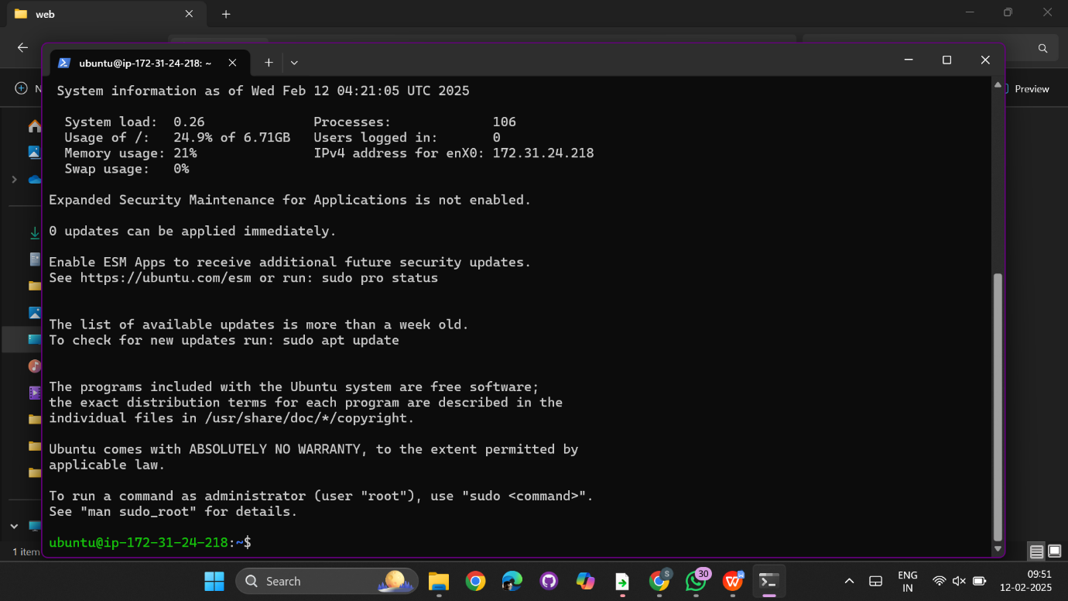  
  
sudo update -y

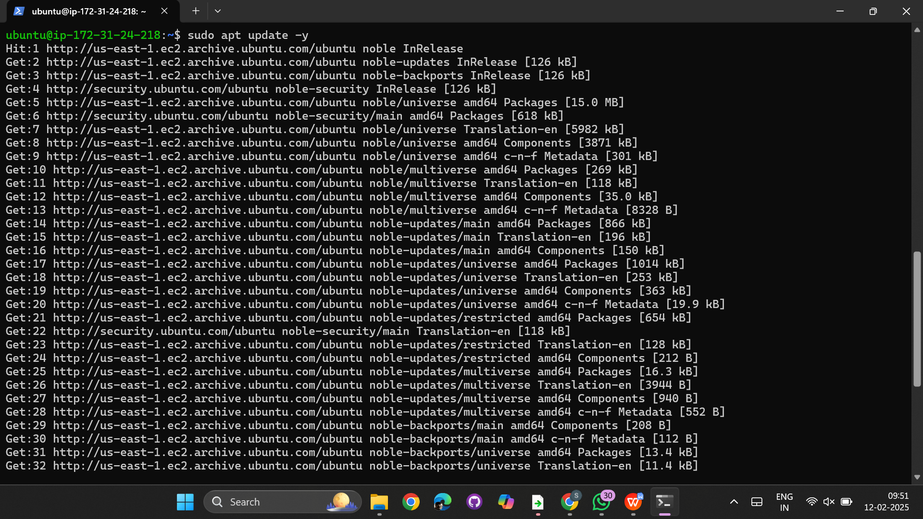

install docker in ubuntu  
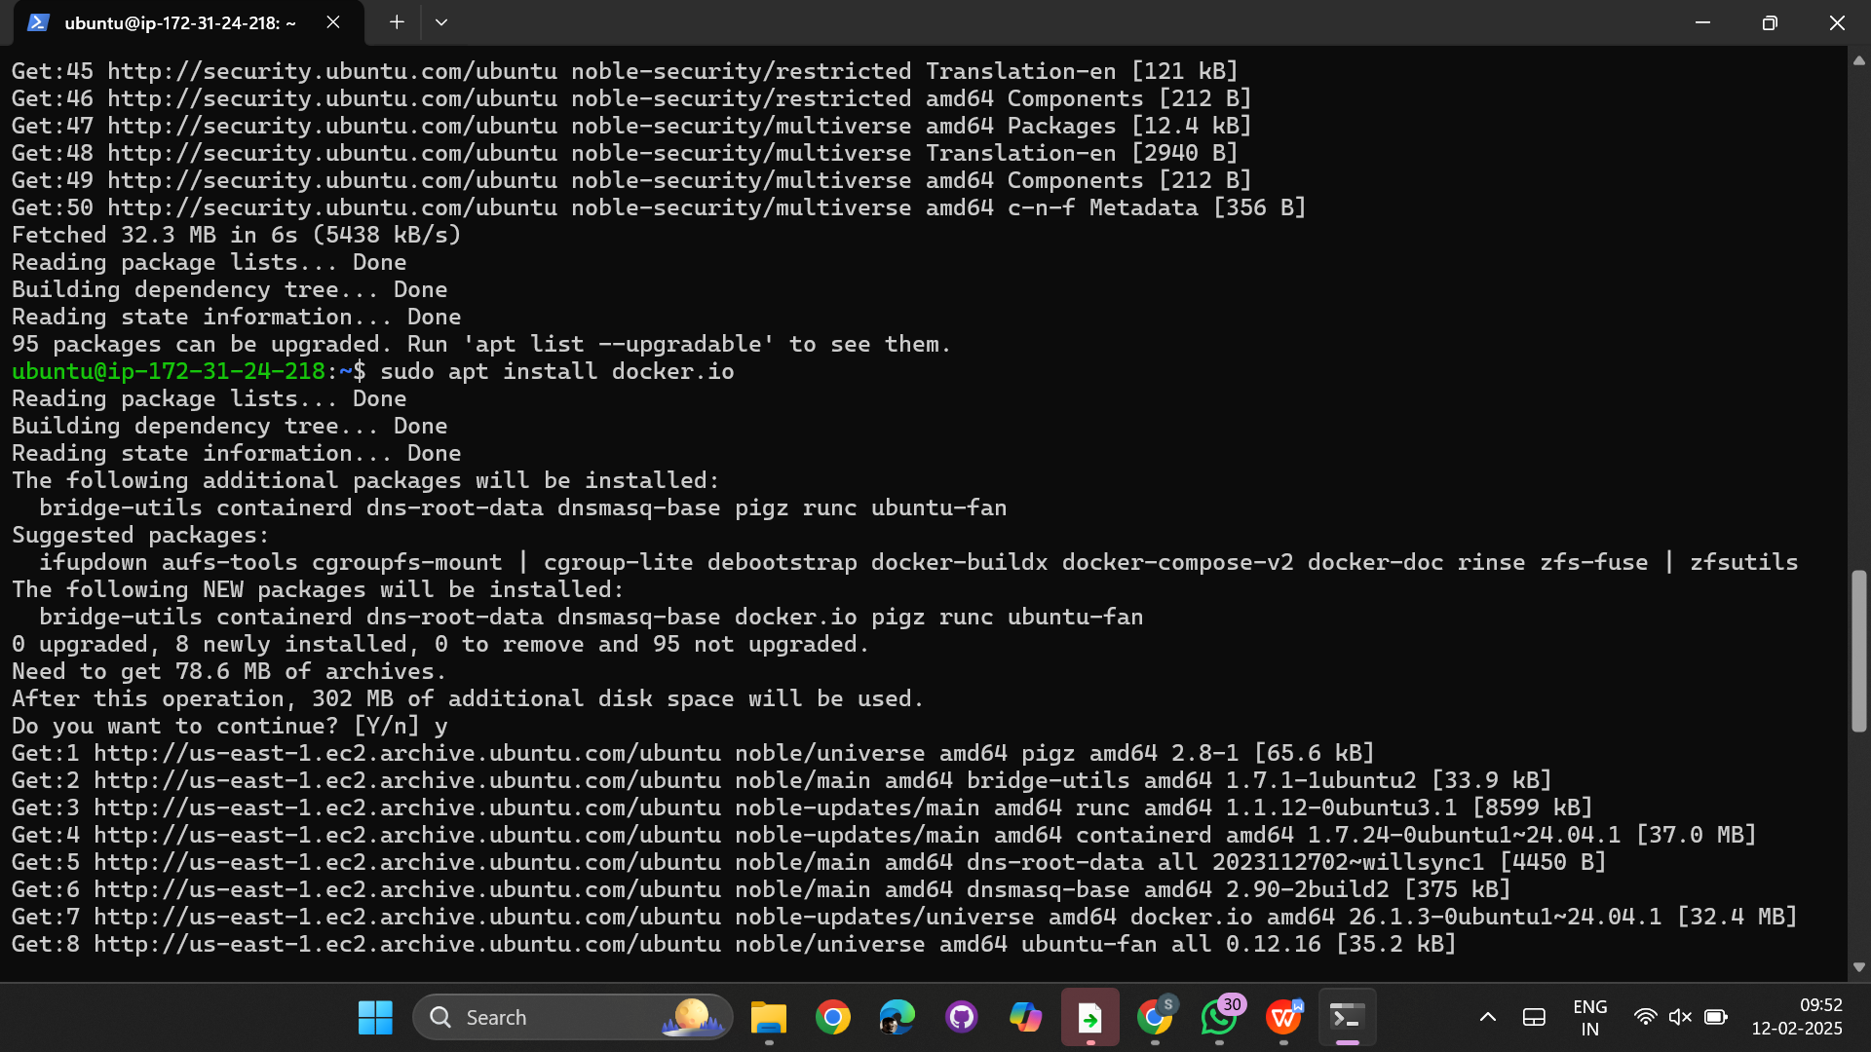  
  
  
pull nginx using docker  
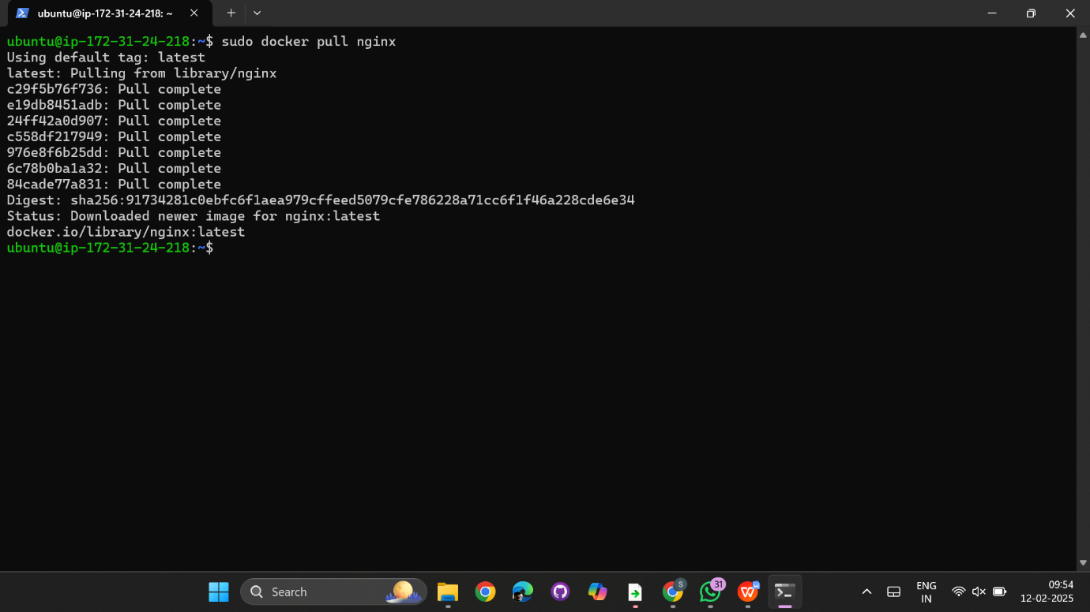

using public ipv4 in EC2 instance open it in browser  
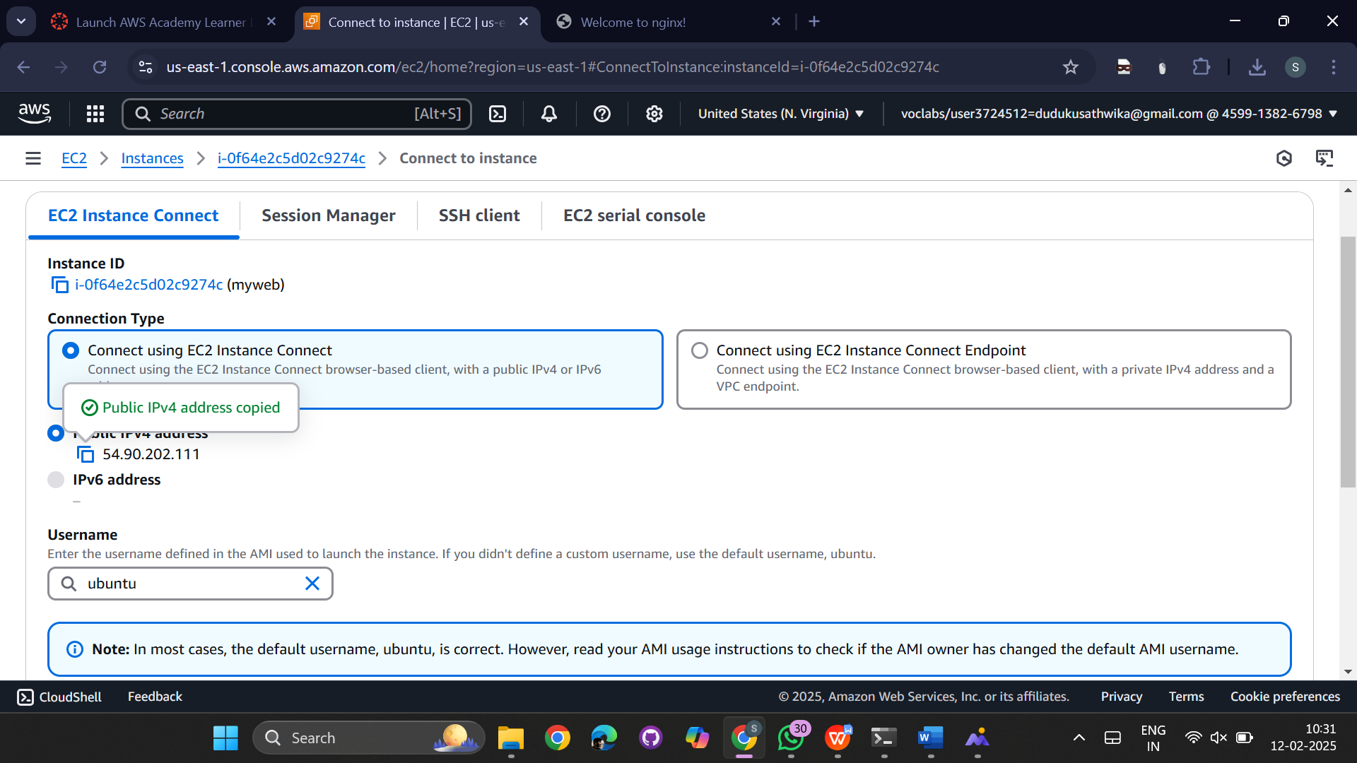  
  
open nginx in browser  
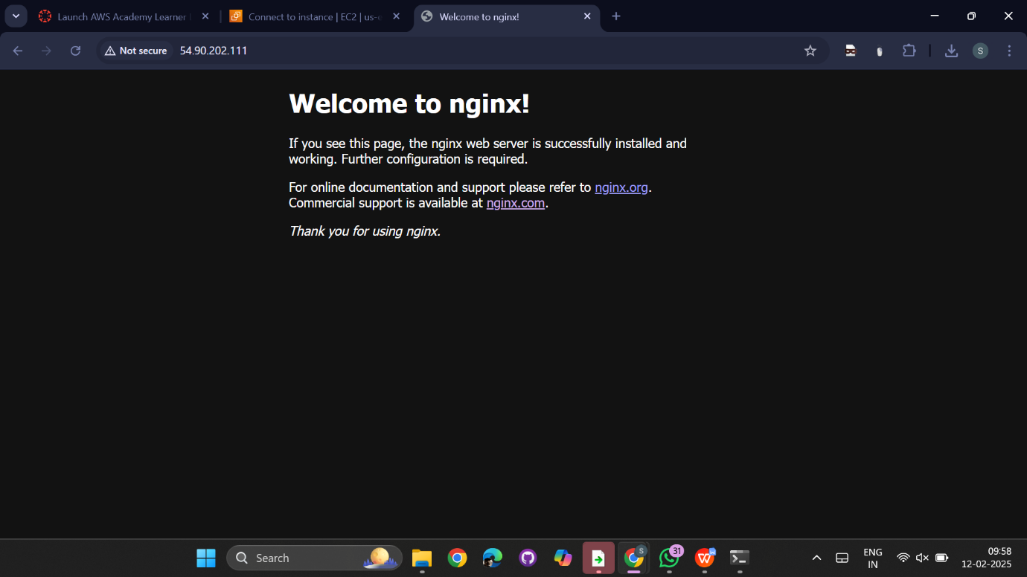  
  
  
run the nginx container and navigate to usr/share/nginx/html list out the file in the directory  
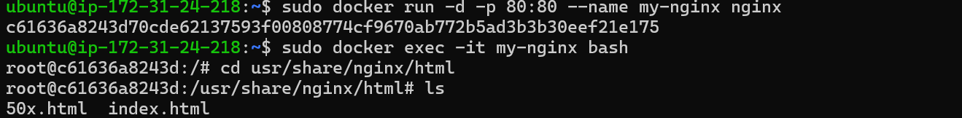

open the index.html file  
  
  
use ‘i’ for inserting data in html and ‘esc’ for exit  
change welcome to mynginx to roll number  
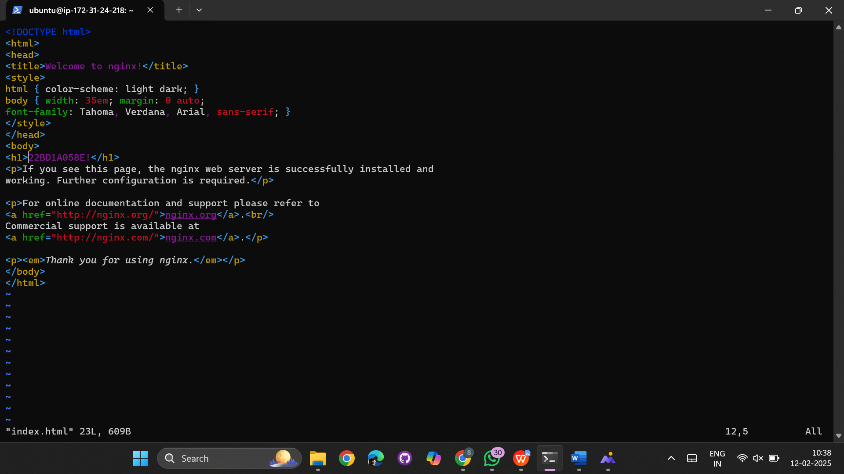  
  
  
open the nginx in browser using ec2 public ipv4 address  
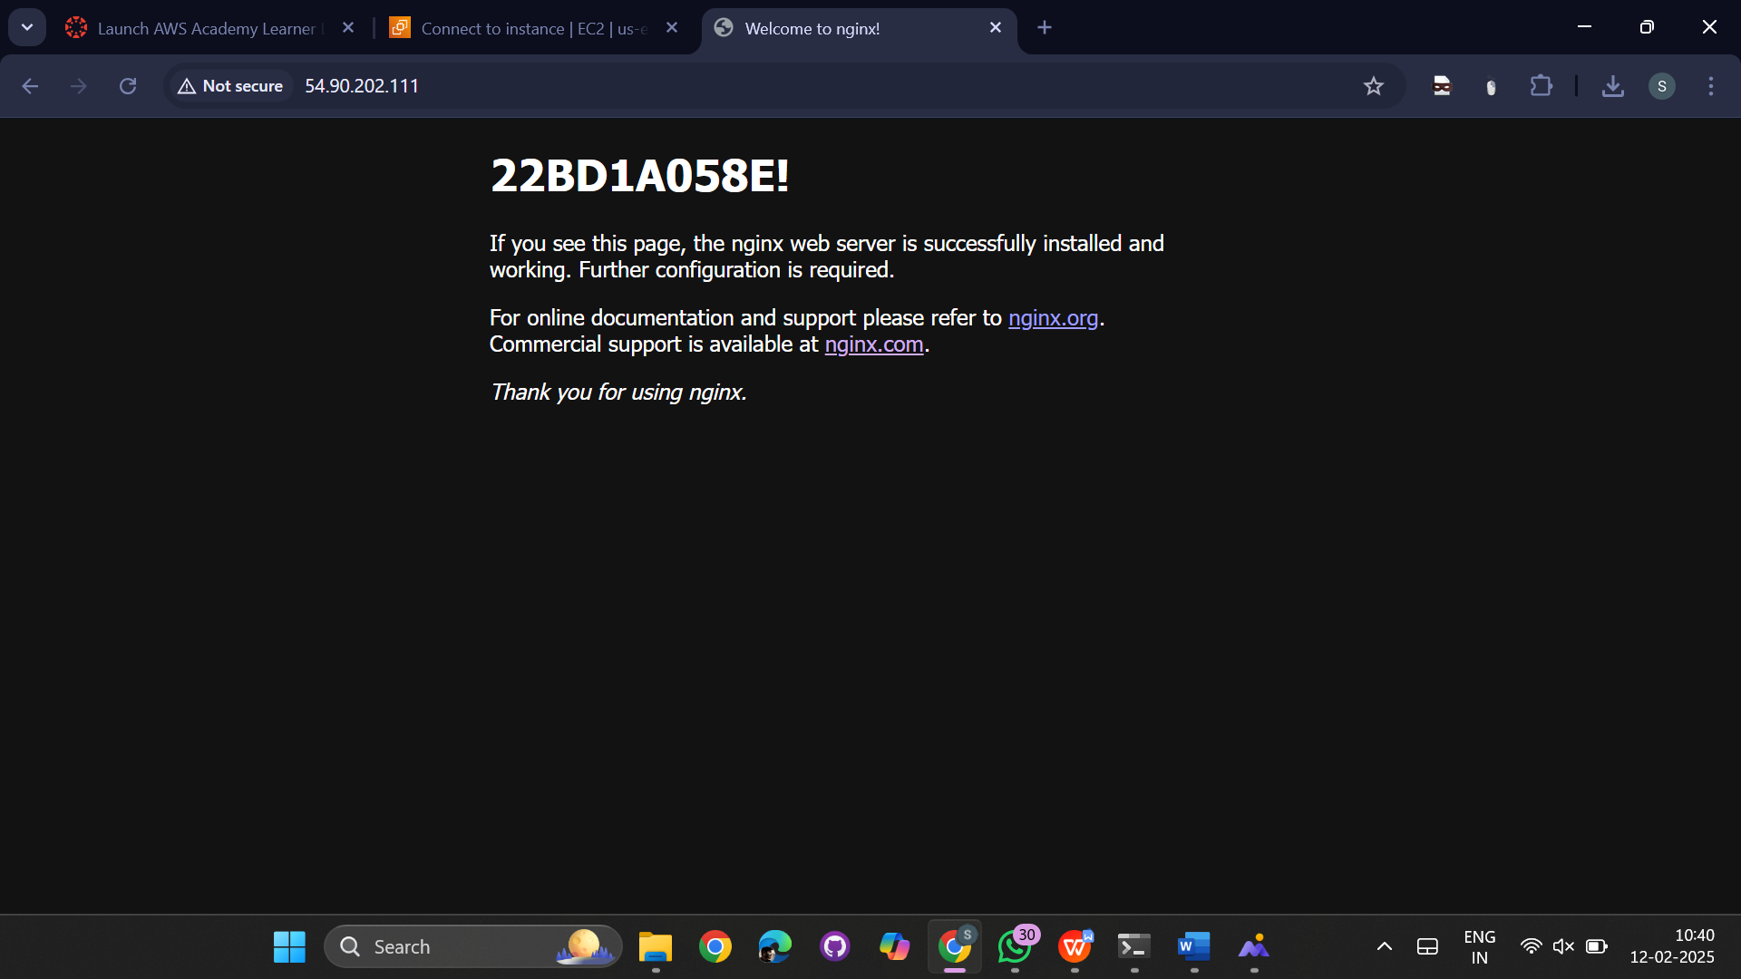

link for nginx: http://54.90.202.111/

direct connect:  
go to EC2 instance and click on connect

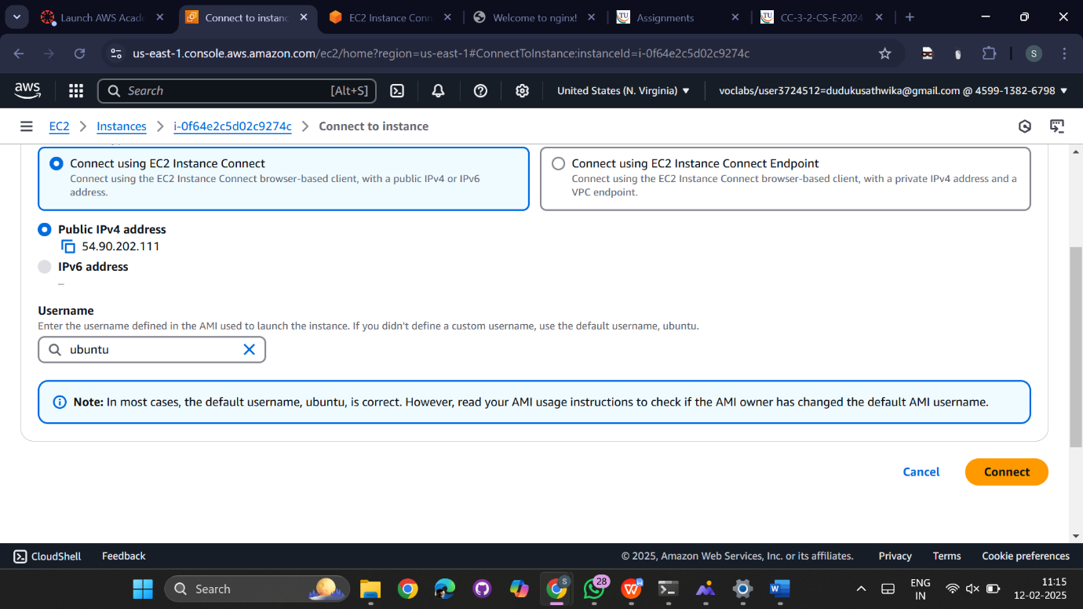

The terminal will open directly  
